Aryan Chaudhari
372012

 | Bansilal Ramnath Agarwal Charitable Trust’s Vishwakarma Institute of Information Technology  Department of  Artificial Intelligence and Data Science
Student Name: Sathe Onkar Abasaheb
Class: TY | Division: B |  | Roll No: 372078
Semester: V |  | Academic Year: 2025-2026
Subject Name & Code: Cyber Security (AD31234B)
Assignment No: 03
Title of Assignment: Study and explore Cryptool and AVISPA tools.

Date of Performance: 21/07/2025 |  | Date of Submission: /08/2025

Aim: To understand and explore tdhe working of CrypTool and AVISPA tools used in cryptographic and security protocol analysis.
Objective: The goal of this assignment is to gain practical knowledge and theoretical understanding of cryptographic algorithms using CrypTool, and security protocol validation using the AVISPA tool.

Materials Required:
A computer system with internet connectivity.

Theory:-
- CrypTool

Overview of CrypTool
CrypTool is an open-source software platform created to support the learning and demonstration of cryptographic concepts. Launched in 1998, the tool has significantly evolved and now provides an extensive set of features that cover both classical encryption methods and modern cryptographic techniques. CrypTool has multiple variants such as CrypTool 1 (CT1), CrypTool 2 (CT2), and an online version known as CrypTool Online (CTO), making it accessible across various devices and platforms. It is a widely adopted educational resource in universities and IT industries.

Features and Algorithm Support
    - Interactive Learning:
CrypTool makes learning engaging by allowing users to run simulations of various cryptographic algorithms. This helps visualize how encryption and decryption take place.

Diverse Algorithm Support:
CrypTool supports a wide spectrum of cryptographic methods, categorized as:
      - Historical Ciphers: Caesar, Playfair, Vigenère, etc.
      - Modern Encryption Standards: DES, Triple DES, AES, RSA.
      - Hash Algorithms: MD5, SHA-1, SHA-2 families.
      - Asymmetric Encryption: ElGamal, RSA, Diffie-Hellman.
      - Block and Stream Ciphers: Blowfish, AES.

Visualization Capability:
Helps users understand how cryptographic steps unfold through animations and stepwise processes.

Modular Learning Structure:
CrypTool has a flexible design where users can plug in various learning modules depending on what they want to focus on.

Key Modules and Functional Utilities
    - Hands-On Algorithm Modules:
Users can interactively test and experiment with different encryption and decryption methods.

Built-In Tutorials:
Educational resources are integrated into the tool to explain basic and advanced cryptographic ideas, such as key exchange and message verification.

Analysis Tools:
Users can simulate attacks and analyze how secure a particular algorithm is.

Mathematical Utilities:
Tools like modular arithmetic and prime number generators support learning the math behind cryptography.

Network Security Options:
Modules related to SSL, TLS, and VPNs are available for deeper network security education.

Developer Tools:
CrypTool includes programming APIs to help integrate cryptographic features into custom software.

Cybersecurity Applications of CrypTool
    - Academic Learning:
Frequently used in coursework to help students understand the real-world implementation of cryptographic principles.

Corporate Training:
Businesses use it to educate their staff on securing data communication.

Research Support:
Assists researchers in developing and testing new encryption techniques.

Security Assessments:
Can be applied to evaluate the strength of encryption and detect flaws.

Professional Cryptography:
Helps cryptographers experiment with novel algorithms or customize known ones for specific use cases.

AVISPA Tool

Introduction to AVISPA

AVISPA stands for Automated Validation of Internet Security Protocols and Applications. It is a powerful tool developed under a European research initiative to assist in validating the security properties of network protocols. The tool automates the detection of flaws and performs formal analysis using simulations and attack models. It ensures that the communication protocols meet standards like confidentiality, integrity, and authentication.

Input Language:
AVISPA uses HLPSL (High-Level Protocol Specification Language), a formal language for defining security properties and protocol behaviors.

Purpose and Working of AVISPA
AVISPA is mainly used to check the reliability and safety of communication protocols. It identifies potential security flaws by simulating various attacks and evaluating if the protocol can withstand them. It automates testing through formal models, saving time and increasing precision.

AVISPA's Back-End Tools
AVISPA uses four advanced engines for protocol validation:
    - OFMC: On-the-fly Model Checker for exploring attack scenarios.
    - CL-AtSe: Constraint-logic-based Attack Searcher.
    - SATMC: SAT-based Model Checker using Boolean logic.
    - TA4SP: Tree Automata-based analysis tool.

Security Properties Validated
AVISPA evaluates the following properties:
    - Confidentiality: Prevents unauthorized access to sensitive data.
    - Integrity: Verifies that information hasn’t been altered during transit.
    - Authentication: Confirms identities of communicating parties.
    - Freshness: Detects replayed messages by ensuring timeliness.

Functional Components
    - Protocol Editor (HLPSL): Write and edit protocol definitions.
    - Simulation Panel: Test protocols against predefined attack models.
    - Automatic Evaluation: Uses backend tools to check for compliance.
    - Attack Trace Generator: If a weakness is found, the tool provides a step-by-step trace.
    - Reports and Visuals: Produces formatted reports and graphical outputs for easy understanding.

Pros and Cons of Using AVISPA Advantages:
    - Fully Automated: Reduces manual effort and human error.
    - Deep Analysis: Uses multiple engines for comprehensive security checks.
    - Flexible Input: HLPSL provides detailed control over protocol modeling.
    - Insightful Output: Helps visualize and understand vulnerabilities through attack traces.

Limitations:
    - Steep Learning Curve: Requires knowledge of HLPSL and formal logic.
    - Scalability Issues: May lag when analyzing extremely complex or large protocols.
    - Narrow Scope: Limited to protocol validation; doesn't cover broader cryptographic areas.

    - Result Complexity: Output may require background knowledge to interpret correctly.

CrypTool Exploration:-

Step 1: Installation

Visit the official CrypTool download page and install the tool:
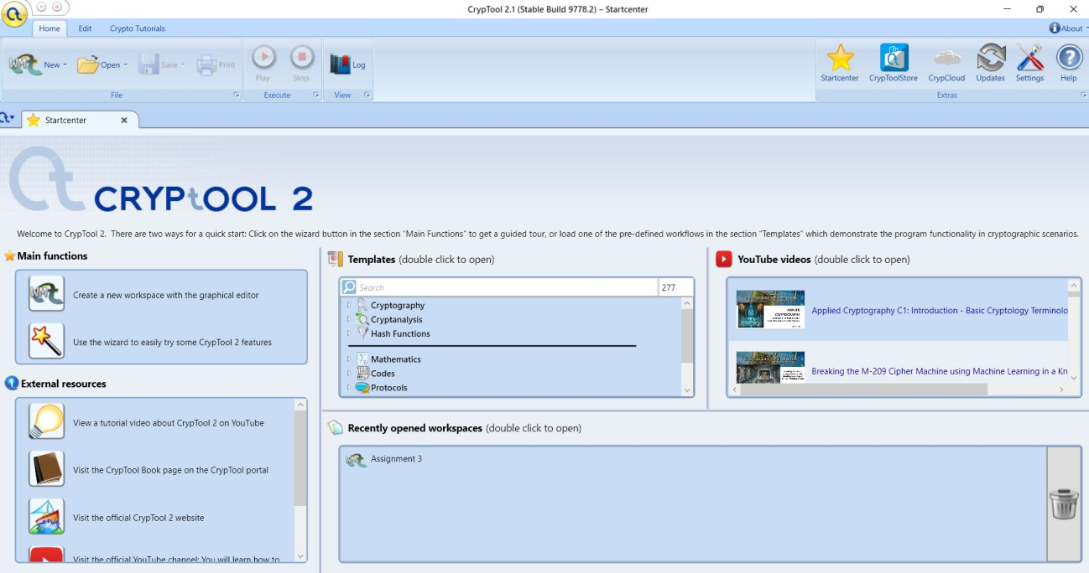

Step 2: User Interface Overview
After installation, open CrypTool and examine the starting page and menus.
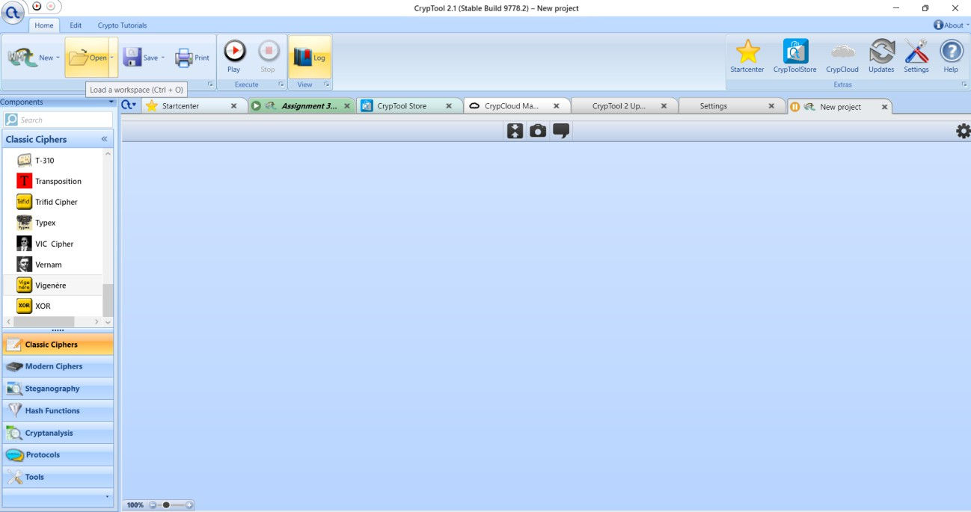

Experiment with different cryptographic algorithms and encryption decryption processes using cryptool:-

- Ceaser cipher
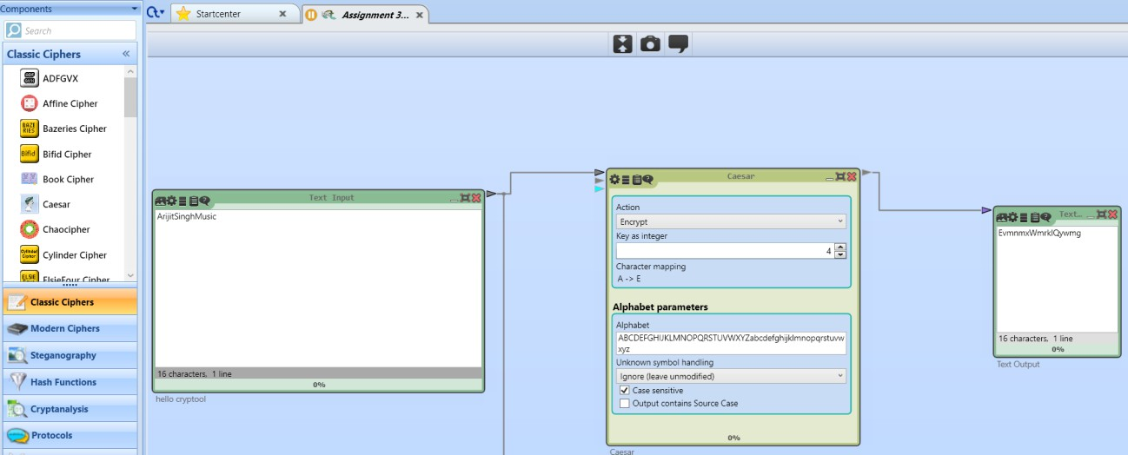

The Caesar Cipher is one of the simplest and oldest encryption techniques. It is a monoalphabetic substitution cipher where each letter in the plaintext is shifted a fixed number of positions down the alphabet. Julius Caesar used it with a shift of 3 to protect his military messages.

Example (Shift = 3):
  - Plaintext: HELLO

Ciphertext: KHOOR

- Playfair cipher:
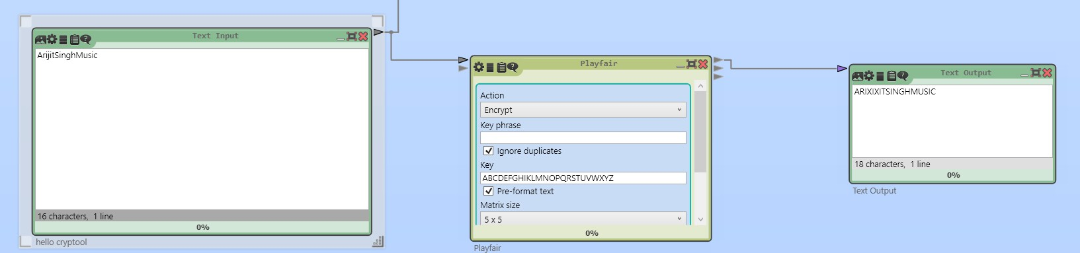

The Playfair Cipher is a digraph substitution cipher that encrypts pairs of letters instead of single letters. It uses a 5×5 grid of alphabets built using a keyword (usually combining I and J). This cipher was designed to make frequency analysis more difficult by working with letter pairs.

Example:
  - Keyword: MONARCHY
  - Plaintext: HELLO
  - Ciphertext: DMSPZN
The Playfair cipher offers better security than monoalphabetic ciphers and was used in military communication during World War I and II.

ignere cipher:-
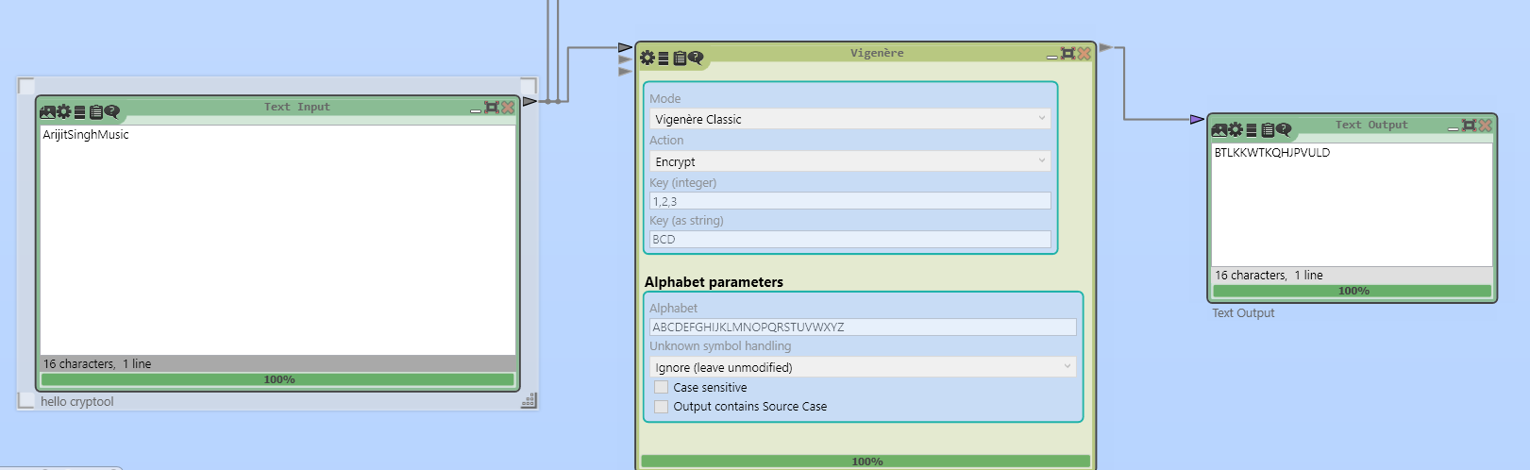

Vigenère Cipher:
The Vigenère Cipher is a polyalphabetic substitution cipher that uses a keyword to determine the shift for each letter in the plaintext. It enhances security by applying multiple Caesar ciphers in a sequence using the letters of the keyword.

Example:
  - Plaintext: ATTACKATDAWN
  - Keyword: LEMONLEMONLE

Document your observations and discuss the usability and effectiveness of Cryptool as a learning and testing tool.
Usability of Cryptool
  - User-Friendly Interface: Easy-to-navigate GUI suitable for all levels of users.
  - Comprehensive Tutorials: Step-by-step guides enhance learning, especially for beginners.
  - Interactive Simulations: Real-time experimentation with cryptographic algorithms.

Effectiveness of Cryptool
  - Educational Value: Strong tool for teaching and learning cryptography, with practical applications.
  - Broad Algorithm Support: Extensive range of classical and modern cryptographic algorithms.
  - Visualization Tools: Helps in understanding complex concepts through visual representations.
  - Practical Testing: Useful for testing and analyzing cryptographic methods in real- world scenarios.
  - Research and Development: Facilitates experimentation and innovation in cryptography.

Avispa Tool Exploration:-
- Access the Avispa tool online or download it to your computer , if available.

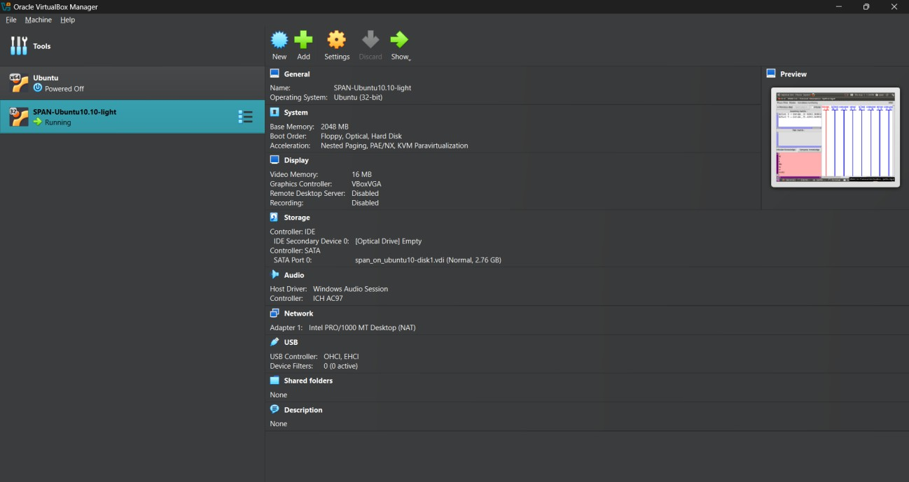

- .Familarise yourself with the AVISPA tool interface and functionalities
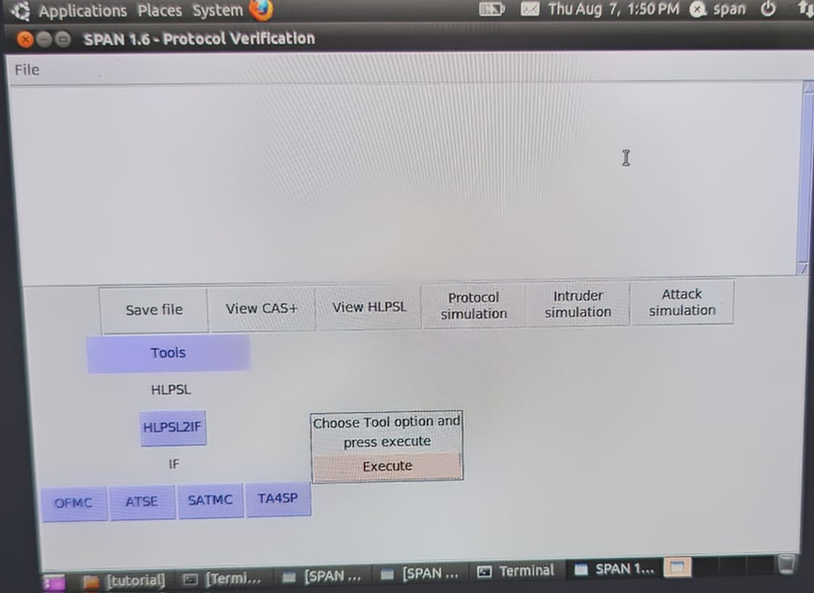
- Perform basic security protocol analysis using AVISPA

The initial HSPSL in the protocol simulation window

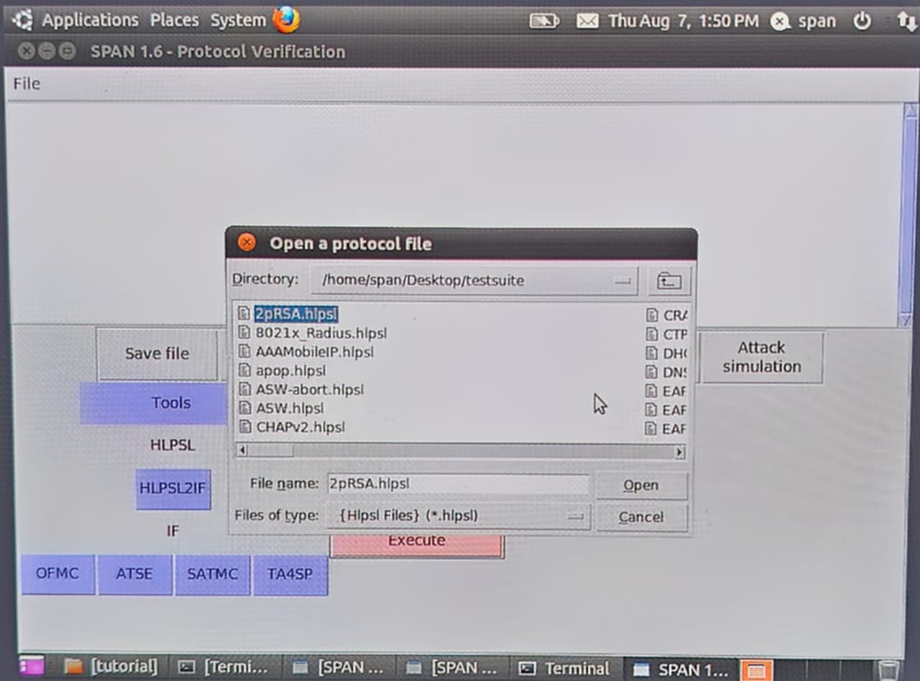

After Execution:-
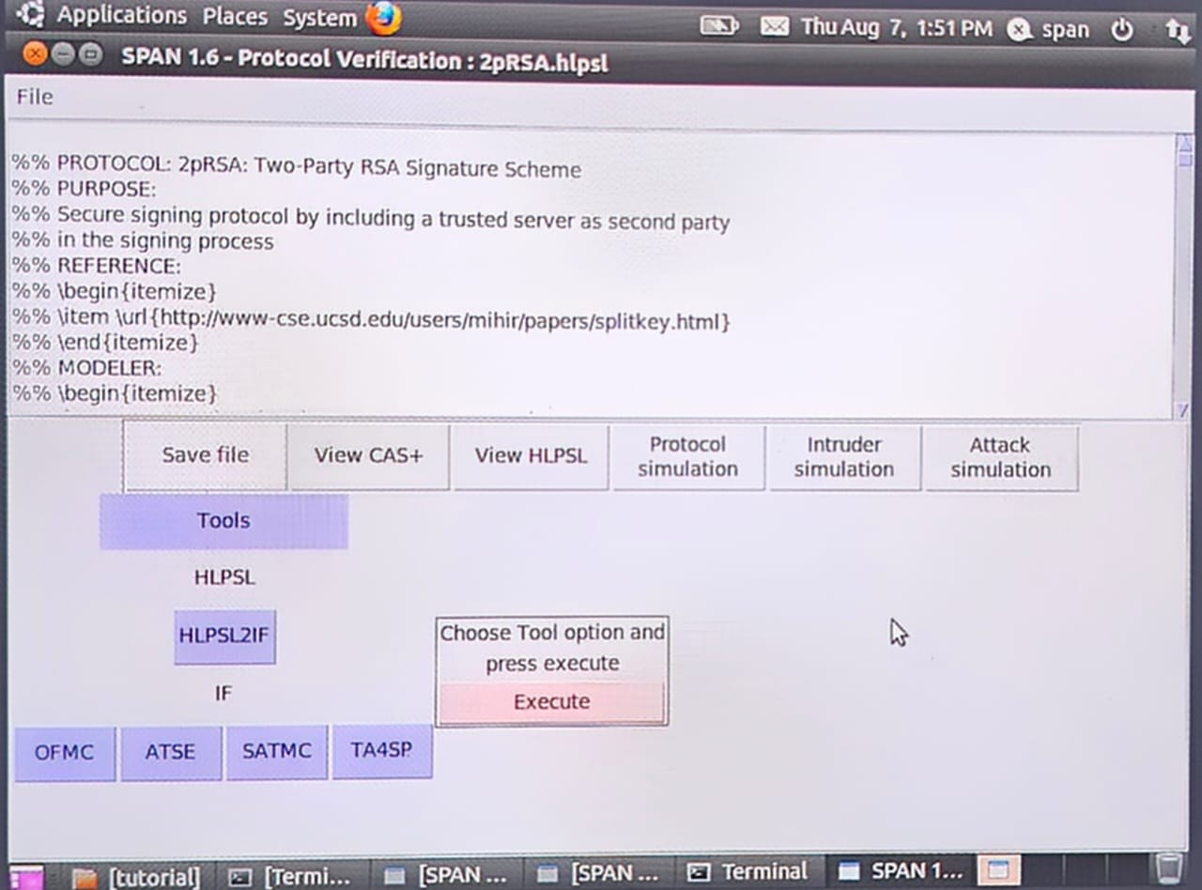

The HSPSL obtained after sending the first (and unique) message

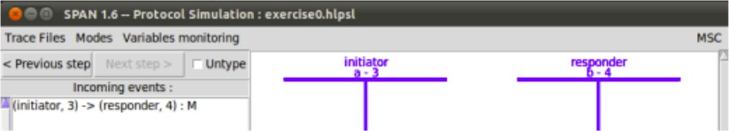

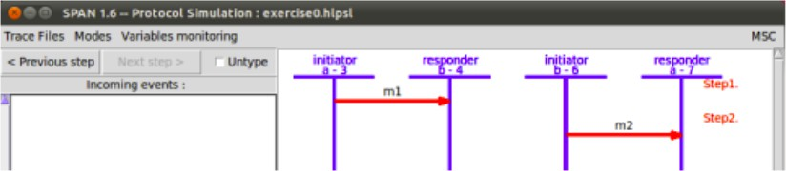
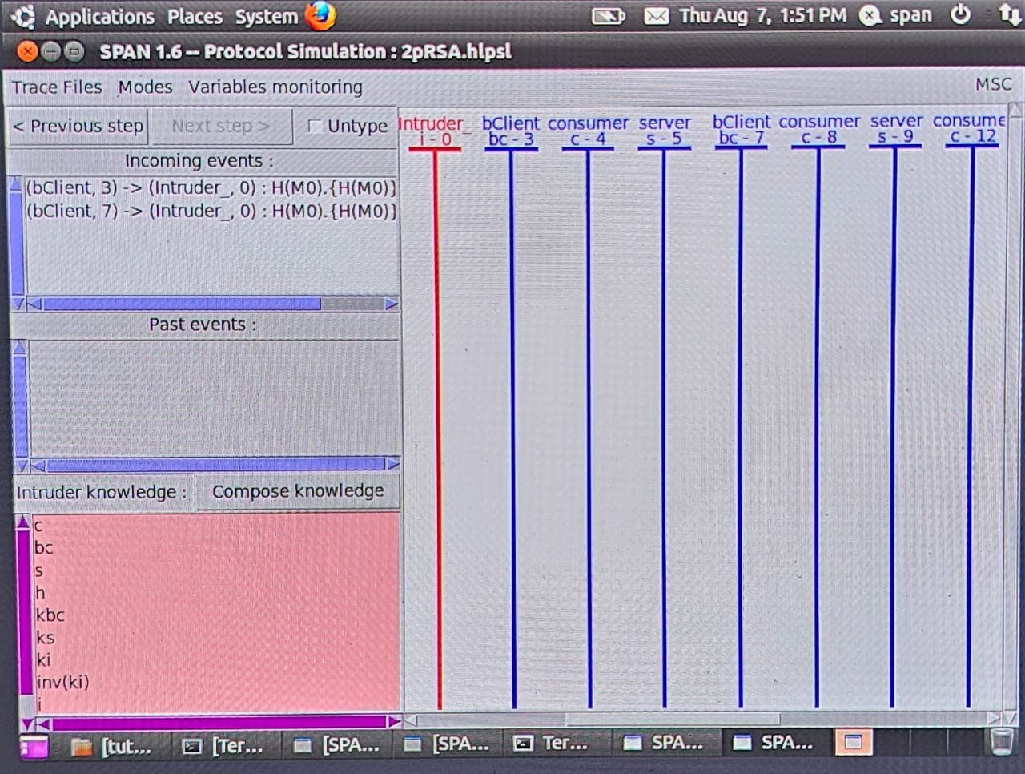

Document your experience and discuss the usefulness of AVISPA in verifying security properties of protocols.
  - Effective Protocol Verification: Ensures security properties like confidentiality and authentication.
  - Automated Analysis: Reduces manual effort with comprehensive, automated protocol verification.
  - Detailed Attack Traces: Provides insights into potential vulnerabilities and attack methods.
  - Multiple Back-end Tools: Enhances analysis accuracy through diverse approaches.
  - Research & Development: Supports protocol design and testing in academic and industrial settings.
  - Security Audits: Validates and strengthens existing protocols during audits.

Conclusion:

Cryptool and AVISPA are both powerful tools in the realm of cryptography and security protocol analysis. Cryptool excels as an educational and practical tool, providing an intuitive and interactive environment for learning and testing a wide range of cryptographic algorithms. Its usability and effectiveness make it ideal for students, educators, and professionals alike. On the other hand, AVISPA is a specialized tool designed for the automated verification of security protocols. It offers detailed and comprehensive analysis, making it invaluable for researchers and developers focused on ensuring the security of communication protocols. While AVISPA has a steeper learning curve, its ability to automate complex security checks and generate detailed attack traces makes it a critical resource in protocol verification and security audits. Together, these tools enhance the understanding, testing, and validation of cryptographic methods and security protocols, contributing significantly to the field of cybersecurity.

